# Module 7 Activity 1: Generating SSL Certificate and Configuring HTTPS Server in Node.js on Windows

# Brandon Trinkle

# IFT 458: Middleware Programming

# Professor Dinesh Sthapit

# April 3, 2025

# Module 7 Activity 1: Generating SSL Certificate and Configuring HTTPS Server in Node.js on Windows

*Screenshot 1: Showing the OpenSSL installed confirmation.*

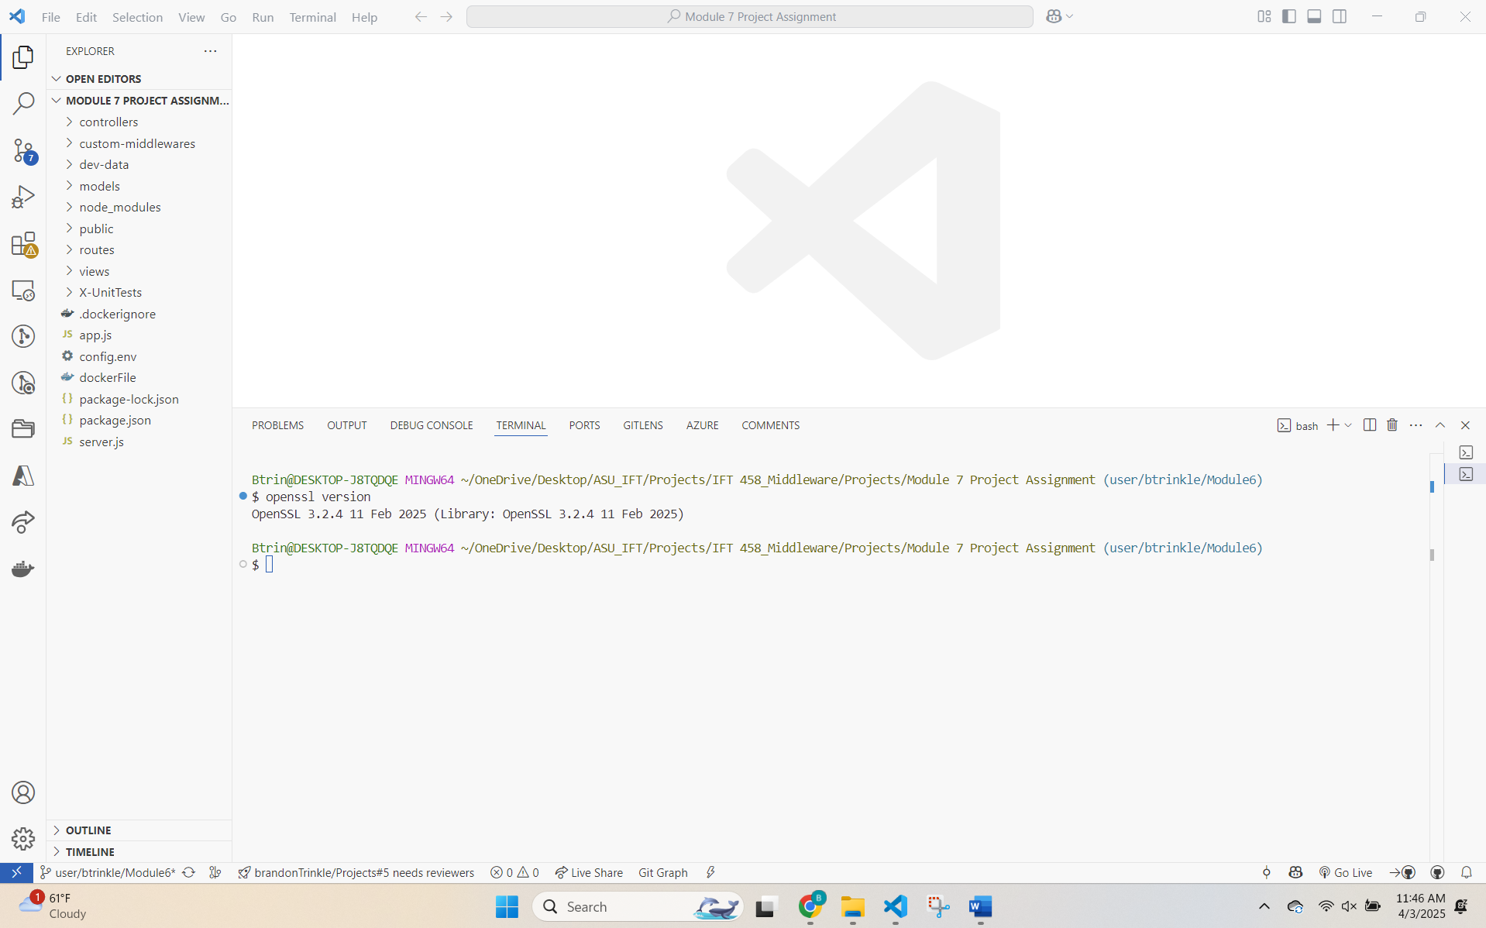

*Screenshot 2: Showing Command Prompt after generating server.key.*

*Screenshot 3: Showing execution of command to generate server.cert.*

*Screenshot 4: Showing filled-in certificate information prompts.*

*Screenshot 5: Showing output of verification commands in Command Prompt.*

*Note: Screenshot contains command line input and output, excluding key and cert information.*

*Screenshot 6: Of the project folder with server.key and server.cert files.*

*Screenshot 7: Showing the modified Server.js file in your IDE.*

*Screenshot 8: Showing the terminal with the running Node.js server.*

*Screenshot 9: Showing the browser view when accessing the HTTPS server.*

*Screenshot 10: Showing the browser's security warning.*

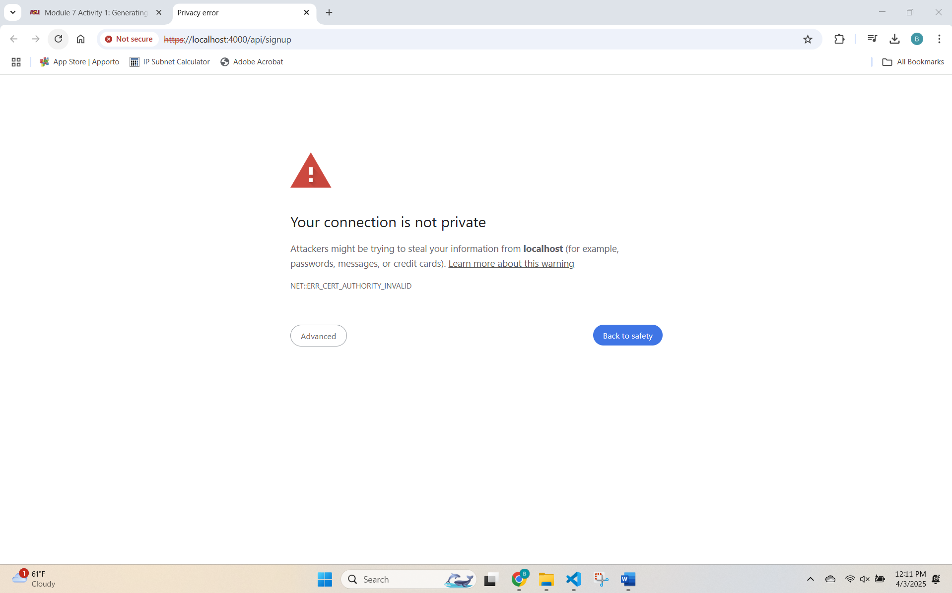

*Screenshot 11: Displaying the URL change after accepting the security warning.*

